Market Research Agent
Solution Kit (No-Code Track)
The demo video for this project is available here.

1. Use Case Overview
The Competitive Intel Agent is a three-phase n8n pipeline that accepts a company name via chat and returns a full competitive intelligence briefing. It first discovers the top three competitors using SerpAPI search and a Groq LLM, then runs a sequential data-collection loop that fetches each competitor’s website, extracts structured data, and summarises recent news, writing each result row to Google Sheets. Once all competitors are processed, a final synthesis phase reads the collected data and produces an opinionated briefing covering pricing, feature gaps, strategic recommendations, and risks.
2. Solution Description
The pipeline combines live web data (SerpAPI + direct HTTP scraping) with three specialist LLM agents — a Groq-powered extractor for structured data, a Gemini-powered news summariser, and a Groq-powered synthesis writer — with Google Sheets serving as the durable intermediate store that bridges the collection loop and the synthesis phase.
The demo video for this project is available here.
3. Architecture
The workflow is shown across three diagrams: Discovery Phase (Part 1), Per-Competitor Collection Loop Body (Part 2), and Synthesis Phase (Part 3). Rate-limit Wait nodes are omitted for clarity.
Part 1 of 3 — Discovery Phase: Chat → Search → Identify Competitors → Loop
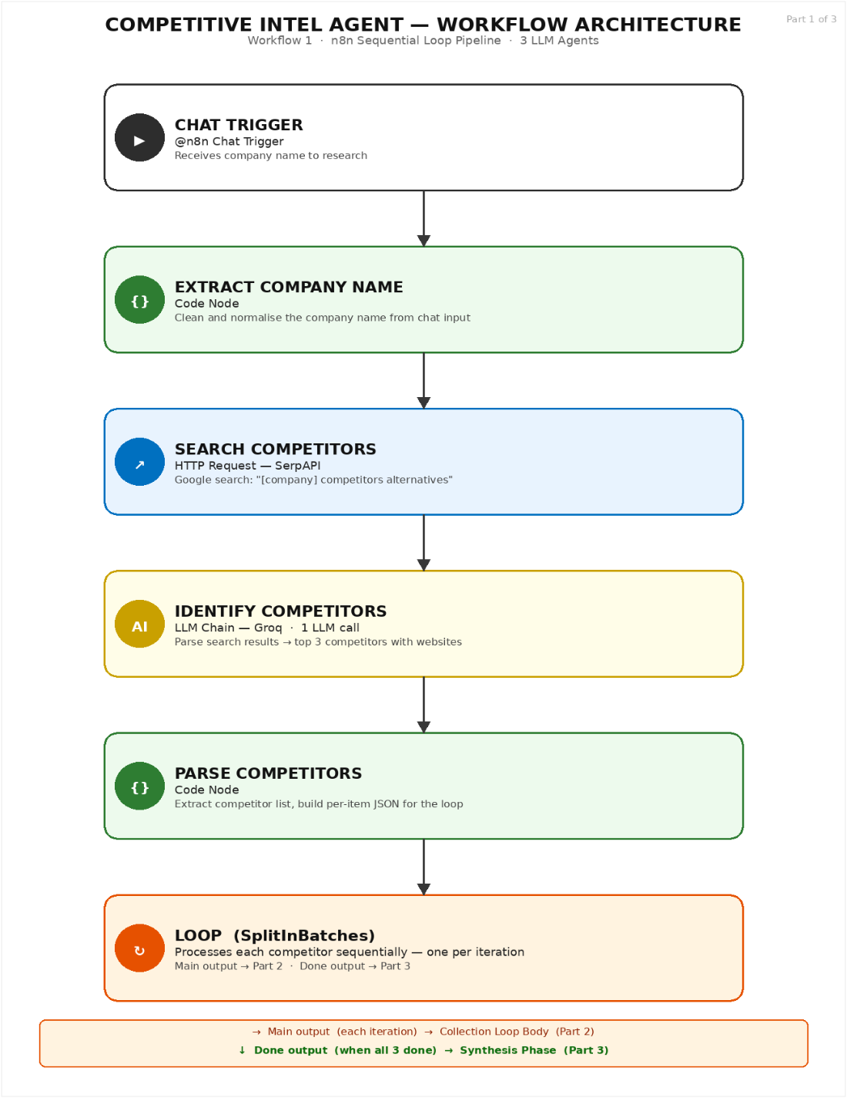
Part 2 of 3 — Collection Loop Body (runs once per competitor)
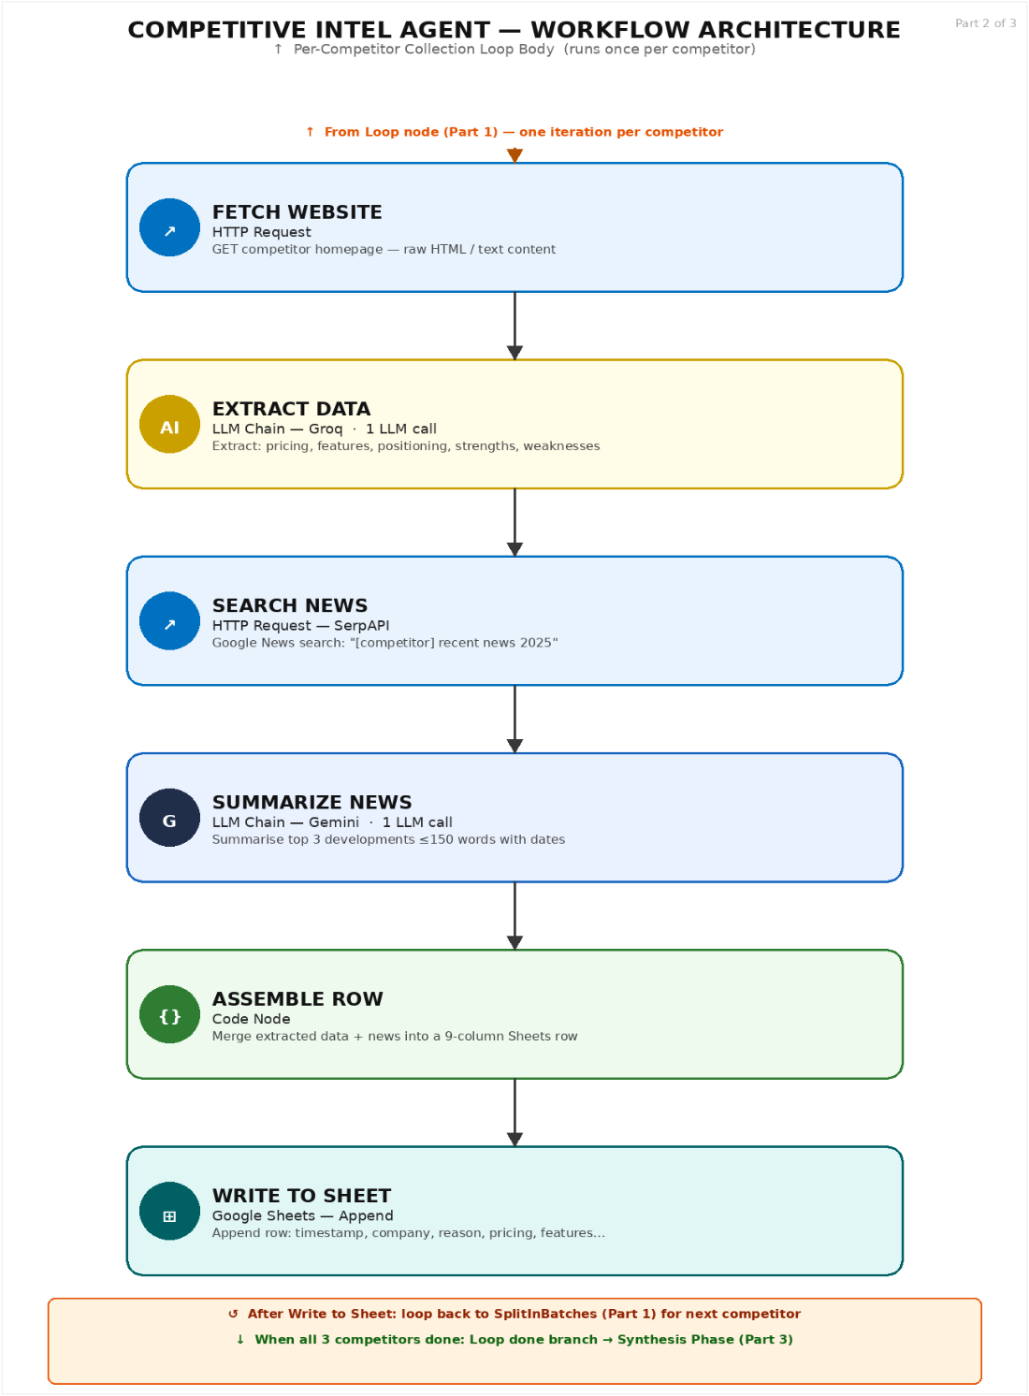
Part 3 of 3 — Synthesis Phase: Read Sheet → Filter → Synthesize → Output
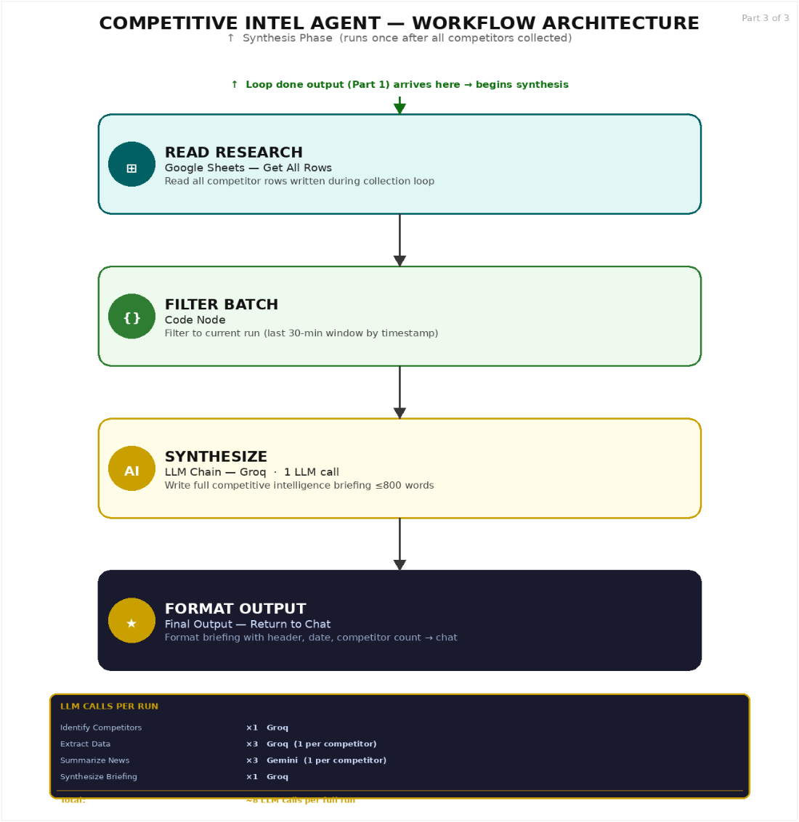
4. Architecture Breakdown
Node Name | Type | LLM / Service | Description
Chat Trigger | Chat Trigger | n8n built-in | Receives company name from user chat interface
Extract Company Name | Code Node | None | Clean and normalise raw chat input to a company name string
Search Competitors | HTTP Request | SerpAPI | Google search: "[company] competitors alternatives" — returns organic results
Identify Competitors | LLM Chain | Groq llama-3.3-70b | 1 LLM call — parse search results → top 3 competitors with website URLs
Parse Competitors | Code Node | None | Extract competitor array, build per-item JSON objects for SplitInBatches loop
Loop (SplitInBatches) | SplitInBatches Node | None | Sequential loop: main branch = one competitor; done branch = synthesis
Fetch Website | HTTP Request | Direct HTTP | GET competitor homepage — raw HTML/text for LLM extraction
Extract Data | LLM Chain | Groq llama-3.3-70b | 1 LLM call per competitor — extract: pricing, features, positioning, strengths, weaknesses
Search News | HTTP Request | SerpAPI | Google News search: "[competitor] recent news 2025"
Summarize News | LLM Chain | Google Gemini | 1 LLM call per competitor — summarise top 3 developments ≤150 words with dates
Assemble Row | Code Node | None | Merge extracted data + news summary into a 9-column row for Google Sheets
Write to Sheet | Google Sheets — Append | Sheets API | Append competitor row: timestamp, company_name, reason, pricing, key_features, positioning, strengths, weaknesses, recent_news
Read Research | Google Sheets — Get All | Sheets API | Read all rows written during collection loop
Filter Batch | Code Node | None | Filter rows to current run using 30-minute timestamp window
Synthesize | LLM Chain | Groq llama-3.3-70b | 1 LLM call — write full competitive briefing ≤800 words: TLDR, landscape, pricing, gaps, moves, recommendations
Format Output | Code Node | None | Add briefing header with company name, date, competitor count → return to chat

Total LLM calls per run: ~8 (Identify ×1 · Extract Data ×3 · Summarize News ×3 · Synthesize ×1)
Node Deep Dives
4.1 Extract Company Name
A Code node that normalises the raw chat input before any API calls. It strips common conversational prefixes ("research", "look up", "find competitors for", "can you", "please") and trailing punctuation, then trims whitespace. This ensures SerpAPI receives a clean company name rather than a full conversational sentence, significantly improving search result quality.
4.2 Search Competitors (SerpAPI)
The first HTTP Request node issues a SerpAPI Google search query combining the company name with the keyword "competitors alternatives". It returns organic search results (titles, URLs, snippets) which the next Groq agent uses to identify the top three direct competitors. SerpAPI is used rather than direct Google scraping because it provides structured JSON results and handles pagination, rate limits, and captcha avoidance automatically.
4.3 Identify Competitors (Groq)
The discovery LLM call. It receives up to 10,000 characters of organic search results and outputs a structured JSON object with three competitors, each including a name, website URL, and one-sentence reason for the competitive relationship.
Output schema
{ "company_summary": "one sentence", "market": "category",
"competitors": [{ "name": "...", "website": "https://...", "reason": "..." }] }
4.4 Loop — SplitInBatches
The SplitInBatches node is the architectural centrepiece. It receives the parsed competitor array (3 items) and processes one item per execution cycle. The main output branch (output 0) carries the current competitor into the collection pipeline; the done output branch (output 1) fires after all items are processed, routing to the synthesis pipeline.
This pattern eliminates the need for explicit iteration logic. Each batch cycle is independent — a failure on one competitor does not affect others — and the loop state is managed entirely by n8n’s SplitInBatches node.
4.5 Fetch Website (HTTP Request)
A direct HTTP GET against the competitor’s homepage URL. The response body is passed to the Extract Data LLM node. The system prompt handles unavailable sites gracefully: if the response is empty or an error, the prompt instructs the LLM to use its training knowledge as a fallback, ensuring the pipeline never hard-fails on an unreachable website.
4.6 Extract Data (Groq)
The second LLM call, executed once per competitor. Receives up to 15,000 characters of website content and extracts five structured data points: pricing (tier names and price points), key_features (top 5), positioning (tagline and target audience), strengths (2–3), and weaknesses (2–3).
4.7 Search News + Summarize News (SerpAPI + Gemini)
Search News issues a SerpAPI Google News query for the competitor. Summarize News uses Gemini (not Groq) to write a 150-word paragraph covering the top 3 developments with specific dates. Gemini is used for this node specifically because it demonstrates stronger recall of recent events and better news-style summarisation with date attribution than Groq at comparable cost.
4.8 Google Sheets as Intermediate Store
After each competitor is processed, Assemble Row constructs a 9-column row and appends it to the Google Sheet. This creates a persistent audit trail and decouples the collection loop from the synthesis phase — if the loop fails mid-way, completed rows are preserved. The Filter Batch node in Part 3 uses the timestamp column to isolate only rows from the current run (30-minute cutoff), preventing older research from contaminating the briefing.
Google Sheets schema
Column | Type | Description
timestamp | ISO datetime | Written by Assemble Row at time of collection
company_name | String | Competitor name from Identify Competitors
reason | String | Why this company is a competitor
pricing | String | Pricing tiers and price points extracted from website
key_features | String | Top 5 features as comma-separated list
positioning | String | Tagline and target audience
strengths | String | 2–3 competitive advantages
weaknesses | String | 2–3 competitive disadvantages
recent_news | String | 150-word Gemini news summary with dates

4.9 Synthesize (Groq)
The final LLM call. Receives the combined research data from all three competitors and writes an opinionated competitive intelligence briefing: TLDR (3 bullets), Competitive Landscape, Pricing Comparison, Feature Gaps, Recent Moves, Strategic Recommendations (3–5 items), and Risks to Watch. The 800-word limit and "direct and opinionated" instruction ensure the briefing is useful to a decision-maker, not just a researcher.
Key Design Decisions
Every significant architectural choice was made deliberately.

Decision Made | Alternative Rejected | Rationale
SerpAPI for competitor discovery and news search | Direct Google scraping or manual input | SerpAPI returns structured JSON and handles captcha / rate limits automatically. Manual input removes the automated discovery value.
Sequential SplitInBatches loop | Parallel fetching of all 3 competitors | Free-tier SerpAPI and LLM rate limits make simultaneous requests unreliable. Sequential also provides clean per-competitor context isolation.
Google Sheets as durable intermediate store | In-memory workflow state | Sheets creates a persistent audit trail. If the loop fails mid-way, completed rows are preserved and diagnosable. Historical comparisons across runs become possible.
Mixed LLM providers: Groq (extraction, synthesis) + Gemini (news) | Single provider throughout | Gemini has stronger recall of recent events and better news-style summarisation with date attribution. Groq is faster and cheaper for structured JSON extraction and long-form synthesis.
Separate discovery phase before loop | Searching inside the loop for each competitor | Discovery phase enables the agent to work for any company without pre-configuration. Identifying competitors inside the loop would re-run discovery on every iteration, wasting API calls.
Timestamp-based 30-minute batch filter | Separate run_id column or clearing the sheet | Timestamp filtering is simpler and preserves historical data across runs. Clearing the sheet would destroy the audit trail.
Website fetch fallback to LLM knowledge on error | Hard fail on HTTP error | Competitive intelligence has value even when a website is down. The LLM’s training knowledge provides a useful baseline without blocking the pipeline.
5. Prompt Library
Three LLM agents use structured prompts. Groq agents enforce ONLY valid JSON output; the Gemini news summariser requests natural language prose.
5.1 Identify Competitors (Groq)
Here are search results about {{ company_name }} and its competitors:
{{ search_results.substring(0, 10000) }}

Identify the top 3 direct competitors.
Respond with ONLY valid JSON:
{ "company_summary": "one sentence", "market": "category",
"competitors": [{ "name": "Name", "website": "https://...", "reason": "why" }] }
5.2 Extract Data (Groq)
Extract data from {{ competitor_name }}'s website:
{{ website_content.substring(0, 15000) }}

Respond with ONLY JSON:
{ "pricing": "tiers and prices", "key_features": "top 5",
"positioning": "tagline and audience",
"strengths": "2-3", "weaknesses": "2-3" }
5.3 Summarize News (Gemini)
Summarize top 3 developments about {{ competitor_name }}:
{{ news_results.substring(0, 8000) }}

Single paragraph, 150 words max. Specific dates. If nothing found, say so.
5.4 Synthesize (Groq)
Competitive intelligence briefing for {{ target_company }}
({{ competitor_count }} competitors). Data: {{ research_data }}

Write: TLDR (3 bullets), Competitive landscape, Pricing comparison,
Feature gaps, Recent moves, 3-5 Strategic recommendations, Risks to watch.
Under 800 words. Direct and opinionated.
Implementation Guide
This guide covers what each phase requires, what to watch for, and how to verify it is working. Use it alongside the architecture diagrams and prompt library.

Prerequisites: A free SerpAPI key (serpapi.com), Groq API key (console.groq.com), Gemini API key (aistudio.google.com), Google Cloud project with Sheets API enabled. Add all credentials to n8n’s credential store before starting.

Phase 1 Set Up the Google Sheet
Create a Google Spreadsheet with a single sheet before building the workflow. It must have exactly 9 columns in order: timestamp, company_name, reason, pricing, key_features, positioning, strengths, weaknesses, recent_news. Column names are referenced by name in the workflow, so they must match exactly.
★ Credential tip: Share the spreadsheet with the Service Account email from your Google Cloud credentials. Without Editor permissions, the Write to Sheet node will fail silently.

Phase 2 Build the Discovery Phase (Part 1)
Build five nodes in sequence: Chat Trigger → Extract Company Name → Search Competitors → Identify Competitors → Parse Competitors.
- Chat Trigger: no configuration needed. The chatInput field holds the user’s text.
- Extract Company Name: Code node that trims conversational prefixes from the input.
- Search Competitors: HTTP Request calling SerpAPI. Query parameter q = "[company_name] competitors alternatives". Pass your SerpAPI key as api_key.
- Identify Competitors: LLM Chain + Groq Chat Model. System prompt from Section 4.1. Add a Wait node (1–2 sec) before it. A Code node after parses the JSON response and builds the competitor array.
- Parse Competitors: Code node that extracts the competitors array and returns one JSON item per competitor for the loop.
★ Test checkpoint: Run with "Notion". Parse Competitors output should contain 3 items, each with competitor_name and competitor_website. If empty, check that Search Competitors returns organic_results.

Phase 3 Build the Loop and Collection Pipeline (Part 2)
Add the SplitInBatches node after Parse Competitors, then build the loop body: Fetch Website → Extract Data → Search News → Summarize News → Assemble Row → Write to Sheet → Wait Loop → back to SplitInBatches.
- SplitInBatches: batch size = 1. Output 0 (main) → loop body. Output 1 (done) → Read Research.
- Fetch Website: HTTP Request. URL = {{ $json.competitor_website }} from the current loop item.
- Extract Data: LLM Chain + Groq. Prompt from Section 4.2. Add Wait node (1–2 sec) before. Code node after parses the JSON.
- Search News: SerpAPI call with tbm=nws parameter and "[competitor] recent news 2025" as query.
- Summarize News: LLM Chain + Gemini. Prompt from Section 4.3. Add Wait node (2–3 sec) before.
- Assemble Row: Code node that builds a flat object with all 9 column values including timestamp = new Date().toISOString().
- Write to Sheet: Google Sheets Append. Map each column name to the corresponding field.
- Wait Loop: Wait 1–2 sec, then wire output back to SplitInBatches input.
⚠ Loop wiring: Wait Loop output must connect back to SplitInBatches main input — not its output. Connecting to the wrong port is the most common loop mistake in n8n.
★ Test checkpoint: Run the full workflow. After one iteration, check the Google Sheet. There should be one row with all 9 columns populated. If columns are blank, inspect Assemble Row output JSON.

Phase 4 Build the Synthesis Phase (Part 3)
Connect SplitInBatches done branch (output 1) to Read Research, then build: Filter Batch → Wait Synth → Synthesize → Format Output.
- Read Research: Google Sheets Get All Rows node reading the full sheet.
- Filter Batch: Code node filtering rows by timestamp within last 30 minutes. Also builds a formatted research_data string and counts competitors.
- Synthesize: LLM Chain + Groq. Prompt from Section 4.4. Passes target_company, competitor_count, and research_data via template expressions.
- Format Output: Code node that prepends a header (company, date, competitor count) to the briefing and returns it via the "output" field.
⚠ Done branch timing: The done branch fires only after all batch items are processed AND the loop re-triggers. If Wait Loop → SplitInBatches is broken, the done branch never fires and synthesis never runs.

Common Errors and Fixes
Error | Most Likely Cause | Fix
Identify Competitors returns parse error | LLM returned text or markdown fences around the JSON | Add regex stripping before JSON.parse. Match /```(?:json)?\s*([\s\S]*?)```/ then fall back to { to } indexing.
Loop runs only once and stops | Wait Loop not connected back to SplitInBatches input | Wire Wait Loop output to SplitInBatches node input port, not its output port.
Synthesis phase never runs | Done branch never fires because loop wiring is broken | Verify Wait Loop → SplitInBatches is correctly wired. The done branch fires only after all items are exhausted and the node is re-triggered.
Write to Sheet fails silently | Service Account lacks Editor permissions | Re-share spreadsheet with Service Account email from Google Cloud Console → IAM.
Filter Batch returns empty array | Assemble Row not writing a timestamp field | Confirm Assemble Row sets timestamp: new Date().toISOString() and that Write to Sheet maps this column.
Fetch Website returns empty | Site blocks scraping or returns non-text | The Extract Data prompt handles this: "Website unavailable. Use your knowledge." Verify this fallback text is in your prompt.
429 rate limit errors | No Wait nodes between LLM or SerpAPI calls | Add Wait nodes: 1–2 sec before Groq nodes, 2–3 sec before Gemini, 1 sec between SerpAPI calls.

Testing Checklist
✓ Chat Trigger receives input and Extract Company Name outputs a clean string with no prefixes or punctuation
✓ Search Competitors returns an organic_results array from SerpAPI
✓ Identify Competitors outputs valid JSON with exactly 3 competitor objects, each with name and website
✓ SplitInBatches loop body runs exactly 3 times
✓ Each loop iteration writes one row to Google Sheets with all 9 columns populated
✓ Fetch Website fallback works: test with an invalid URL — Extract Data should still return JSON using LLM knowledge
✓ Done branch fires after all 3 competitors are processed
✓ Filter Batch returns exactly 3 rows from the current run (not historical rows)
✓ Synthesize returns a structured briefing with TLDR bullets, pricing comparison, and strategic recommendations
✓ Format Output returns the briefing via the "output" key for the Chat Trigger to display
6. Architectures We Considered
Three alternative architectures were evaluated before settling on the chosen sequential loop design with Google Sheets as durable intermediate store.
6.1 Parallel Competitor Scraping
All three competitors are fetched and processed simultaneously instead of sequentially, with results merged before synthesis.
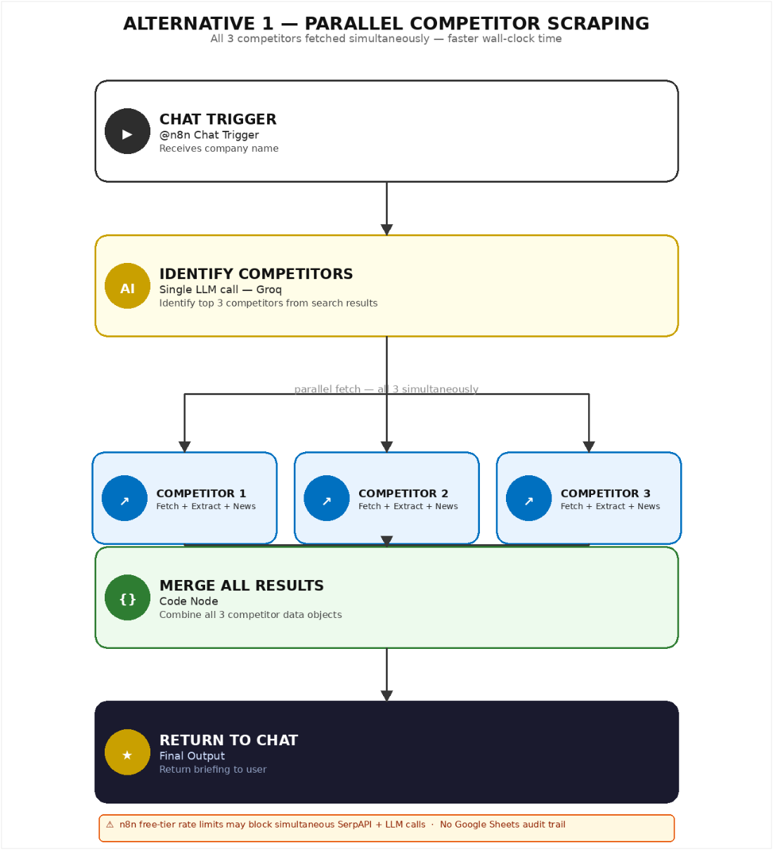

Advantages | Disadvantages
Faster wall-clock — 3 competitors in parallel | Free-tier SerpAPI rate limits: simultaneous calls trigger 429 errors
Simpler flow — no SplitInBatches needed | Simultaneous Groq LLM calls can exceed free-tier token-per-minute limits
Cleaner data — all results at merge point | No per-competitor error isolation — one failure can break all three
Easier to scale to more competitors | More complex merge logic to handle partial failures

6.2 Pure In-Memory (No Google Sheets Buffer)
Competitor research data is held in n8n workflow state throughout the loop, eliminating the Google Sheets dependency.
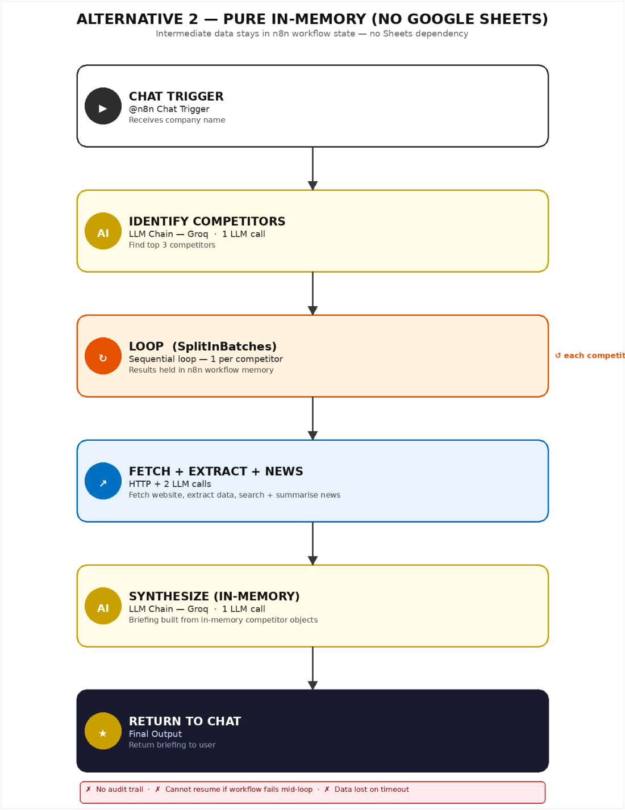

Advantages | Disadvantages
No Google Sheets credential setup needed | No audit trail — data lost when execution completes
Faster — no Sheets round-trips | Cannot resume a partial run if the workflow fails mid-loop
Simpler — fewer nodes | Data lost on timeout (n8n has a max execution time)
No risk of reading stale historical data | Historical comparison across runs is impossible

6.3 Single Monolithic LLM Briefing
One large search call followed by a single LLM call that identifies competitors, extracts data, and writes the briefing in one shot.

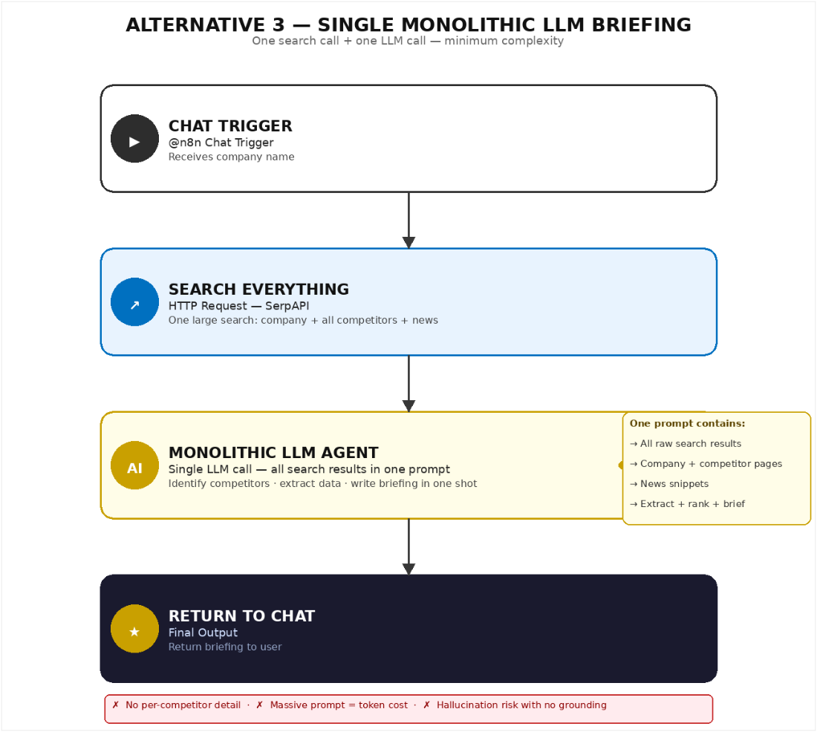

Advantages | Disadvantages
Minimum complexity — 3 nodes total | No live website data or news — purely LLM training knowledge
Fastest execution — one LLM call | High hallucination risk on pricing and specific feature claims
No SerpAPI or Gemini keys needed | Massive prompt = high token cost for a single call
No loop logic required | No structured intermediate data for audit or re-use
7. Future Work
The pipeline reliably produces three-competitor briefings on demand. The following improvements address depth, resilience, and team integration.
7.1 Reliability & Error Handling
Isolate failures per competitor so the loop logs the error and continues. For SerpAPI 429s on the free tier, add configurable back-off with a default 5-second delay and a maximum of 3 retries. Run a nightly n8n cleanup that deletes Google Sheets rows older than 30 days.
7.2 Scalability
Make the SplitInBatches count configurable so requests such as "find 5 competitors" work without workflow changes. Fetch 2–3 pages of discovery results so Identify Competitors has richer signal in niche markets. When rate limits permit, run Search News and Summarize News in parallel to reduce runtime from about 3 minutes to about 1 minute.
7.3 Feature Expansion
Store run_id and target_company in Google Sheets and add a second synthesis call to compare runs. Generate a feature-by-competitor comparison table in a Google Sheet or Markdown output. Ask Gemini to tag each news item as positive, negative, or neutral before summarisation for faster risk-signal filtering.
7.4 Integrations
Post the final briefing to a Slack #competitive-intel channel and tag the requester by chat user ID. Export it to Notion or Google Docs, in addition to or instead of chat, so it persists in the team knowledge base. Cross-reference HubSpot or Salesforce competitor lists and update CRM pricing and positioning data.

